A White Paper on Atmosphere-Related Research in Canadian Universities (ARRCU)
ARRCU Working Group Committee: P. Kushner (chair), P. Gauthier, J. Gyakum, A. Monahan, R. Martin, P. Myers, K. Strong, R. Stull, P. Taylor

Contents
Section | Page
Abstract and Introduction | 1
ARRCU: Definition, Scope and Objectives | 3
Building Capacity and Excellence in ARR | 6
Discovery Research and Research Priority Areas for Partnership | 9
Strategic Planning through Consultation | 13
Education, Training, Communications, and Outreach | 13
Conclusion: Academic ARR in a Changing Environment | 14

Abstract
This White Paper describes a community of Canadian university scientists who carry out atmosphere-related research (ARR) in weather, climate, and air quality. ARR, an enterprise integrating observations, theory, and models, is characterized by strong linkages between fundamental and applied research. A strategic planning initiative is proposed whose overarching goal is to ensure that academic ARR is configured so as to most benefit Canada in light of rapid societal, economic, and environmental change. In this initiative ARR practitioners from universities, government, and industry develop a strategic plan that will be periodically revisited on a five-to-seven year timeframe. The purpose of this strategic plan is to clarify research and related resource priorities, partnership arrangements, and priorities related to education and training for Canadian ARR. The White Paper lays out a draft list of six ARR Priority Areas for Partnership targeted on weather and climate prediction; the Arctic and cold regions; regional hydroclimate, extremes, and weather and climate impacts; air quality research; research on atmosphere-related biogeochemical cycles; and applied research efforts. It then proposes next steps required to put the strategic planning process into effect.

Introduction
Canadians depend in their work and leisure on high quality scientific information about weather, climate, and air quality. Severe weather and marine forecasts, long-term temperature and precipitation assessments, air pollution outlooks, and many other related products and services help Canadians plan everyday activities, make informed business decisions, and develop effective infrastructure designs for their communities. Beyond this, Canadians are inspired and concerned by issues surrounding weather, climate, and air quality. They turn to scientific experts in these areas to understand extreme events (such as the great Québec ice storm of 1998, 2012's Superstorm Sandy, the 2013 Calgary flood, and severe urban air pollution events), variations and changes in climate (such as the effects of El Niño on weather, human-caused global warming and Arctic sea-ice loss), and related impacts (on recent forest fires in the West and the Prairies, on public health, on agriculture, etc.). They also count on these experts to provide guidance on public policy in response to ongoing environmental challenges related to weather, climate, and air quality. There is a strong business case, and a strong case in terms of the public interest and value to society, for ongoing investments to support these services and expertise.
Recognizing this, Canada and other industrialized countries have invested in a nationally and internationally coordinated ‘knowledge resource’ consisting of infrastucture, products, and services related to weather, climate, and air quality. This resource is manifested in operational weather and environmental forecasting, climate and environmental data products, impact assessments, etc., that are readily available to researchers, private citizens, institutions, and communities. This resource is supported by more than a century of research by dedicated scientists in many professional settings including academia, government, and industry. This research, along with major investments in instrument development, measurement systems and computer resources, have over the years greatly improved our observing and forecasting tools in weather, climate, and air quality; these in turn have led to cost savings and commercial activity that enhance our prosperity. Much of this research requires extensive collaboration and resource sharing on a national and international scale. It coordinates large groups of researchers who study how local weather, climate, and air quality conditions ‘here at home’ are linked to global conditions ‘everywhere else’. But often the frontier of this research involves innovation by individual scientists, working on new ideas in laboratories and small research groups, exploring scientific fundamentals, and discovering new ways to make this knowledge relevant to people and communities across Canada and around the world.
The authors and signatories to this White Paper form a group of Canadian university scientists who care passionately about the state and fate of Canada's research in atmospheric and related sciences. The purpose of this White Paper is to synthesize a vision of our research community's plans and priorities in the coming years. It is time to tackle challenging questions such as Where should our research go next? How can university (academic) researchers most effectively partner with government and industry? How do we educate the next generation of students and practitioners? We are addressing these questions in a period of evolving partnerships between university, government, and industry; of changing expectations for research funding; and of transformation in university education. Besides these general trends, in our fields of research in Canada, an important government-university partnership in this area, the Climate Change and Atmospheric Research (CCAR) program of Canada's Natural Sciences and Engineering Research Council (NSERC), is past its half-way point and is being reviewed. We are asking, and are being asked, if the CCAR approach should be renewed with new resources. In addition, the Government of Canada is undertaking a comprehensive review of fundamental science research in Canada under the auspices of the "Advisory Panel for the Review of Federal Support for Fundamental Science,” to address program gaps and seek insight from international practice. In the context of these reviews, it is critical to put time and effort into strategic planning for our fields of research.
In this White Paper we will outline the perspective that our community, ‘Atmosphere-Related Research in Canadian Universities’ (ARRCU), has put forward to develop a strategic plan for research in atmospheric and related sciences in the areas of weather, climate, and air quality. The work leading to this White Paper started with a 2014 Montréal workshop hosted by the U.S.-based University Corporation for Atmospheric Research and culminated in a 2015 workshop sponsored by the Natural Sciences and Engineering Research Council of Canada (NSERC) and other organizations. (Some background information, gathered for the 2015 ARRCU workshop, is available at http://tinyurl.com/arrcu-may2015-workshop and a workshop report can be found at http://tinyurl.com/arrcu-CMOS-Bull-2016.) The authors of this White Paper are the ARRCU working group's organizing committee; we have had input from many others, and those who have signed onto the White Paper (see Table 1) support the viewpoint it outlines. It will take time and work with our partners to produce a detailed strategic plan in atmosphere-related research (ARR) in Canada. But each step along this path has been stimulating and we are confident that this effort will lead to improved organization, coherence, clarity, and focus of our work.
Next we will define the aims of the ARRCU community and outline directions for our priorities in the coming years. The intended readership of this White Paper is the ARRCU community itself, our partners in government and industry, our university administrators and colleagues in other fields, and our colleagues around the world. We hope that its key messages are also understood by the general public. We appreciate any feedback you, the reader, can share with us to help make our message clear and straightforward. Please send comments to the ARRCU Working Group Committee, whose contact information can be found at the end of this document.

Atmosphere-Related Research in Canadian Universities: Definition, Scope and Objectives
The ARRCU community is a group of researchers in Canadian universities working on fundamental and applied scientific research in themes relevant to weather, climate, and air quality. Many of us focus our research on the atmosphere, which is the natural system that supplies the environment for the air we breathe and the weather events and climate conditions we experience. But the atmosphere cannot be studied in isolation. So included in our group are many others who study natural systems connected to the atmosphere, such as the oceans; solar-terrestrial interactions; systems related to the land surface such as forests and soils; hydrologic systems such as lakes, rivers, and wetlands; and frozen systems such as sea ice, snow, glaciers and permafrost (which are especially relevant to Canadians). We also study related human systems that interact with the atmosphere, for example the chemical systems contributing to anthropogenic emissions, and the response of the atmosphere to changes in these emissions. We research the physical, biological, and chemical processes controlling and connecting these systems – a technical term to describe many of these coupled processes is biogeochemical. Our science draws on advanced mathematics and statistics, cutting edge laboratory facilities, development of new instruments and measurement systems for laboratory and field work, networked ground- and space-based observations, coordinated field observation campaigns, and numerical model simulations carried out on advanced research computers. ARR is “Big Data” science requiring ready access to petabyte-scale archives of observational and simulated data. Given the many systems, processes and techniques involved, research in weather, climate, and air quality, ARR needs to coordinate many elements to be done well. Terms we can use to describe this kind of research are integrative, interdisciplinary, and multidisciplinary. The green shaded table in Figure 1 summarizes the definition of ARR.
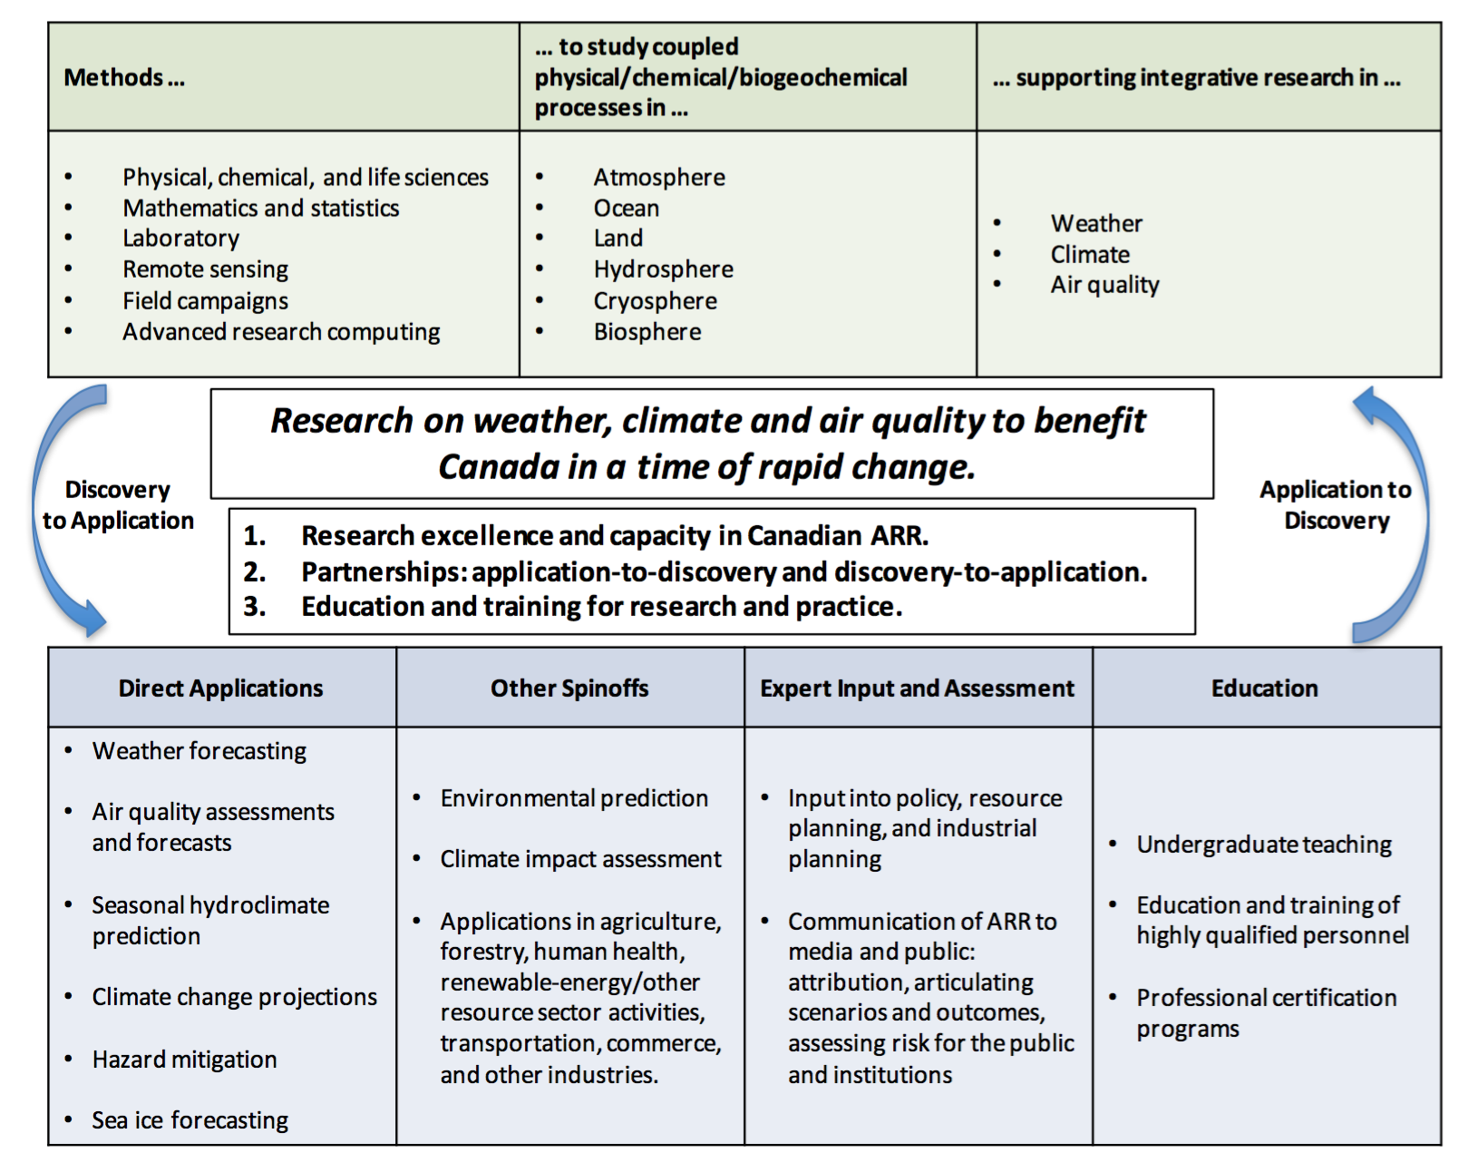
Figure 1: Scope and framework for university-based ARR
The blue shaded table in Figure 1 summarizes various applications, including products, services, and professional roles that are informed by academic ARR. Daily forecasts of weather, outlooks of pollutant distribution, and prediction of seasonal climate, come directly from observations and computer models of the atmosphere, oceans, etc. While these are typically produced by government departments such as Environment and Climate Change Canada (ECCC), and used by individuals and industry, University-based research continually contributes to improving these products. A wide range of spinoffs, developed inside and outside universities, add value to these products. These spinoffs include economic and environmental prediction for industry, agriculture, human health, renewable energy and other resource sector activities, transportation, commerce, and other industries. In common with our government and industry colleagues, many university-based researchers in ARR lend scientific expertise to policy development, resource planning, and industrial planning in Canada and around the globe. We also work to communicate our research to institutions and the public, and share our scientific expertise on weather, climate, and air quality. Finally, an important role for us, particularly in the universities, is in post-secondary education: we introduce undergraduate students to our fields to excite their curiousity and inform them as citizens; and we train undergraduate students, graduate students, postdoctoral fellows, and other highly qualified personnel (HQP) in research, forecasting practice, and other areas.
Weather forecasts, climate predictions, and the related products and services we have been discussing are so easily available that they can be taken for granted. Canadians today are benefitting from many decades of investments in ARR, but ongoing financial investments and coordinated effort are needed to ensure that Canadians will continue to receive the benefits that advancement of ARR can bring. Academic researchers have long pointed out that investments in fundamental and applied ARR have a proven track record of leading to valuable applications. But more recently, we have sought to engage and listen to our partners in private companies, government laboratories and forecast centres to stimulate key directions for fundamental research. The arrows in Figure 1 highlight a two-way connection, from discovery to application and from application to discovery. As scientists engaged in fundamental research, we believe that curiosity-driven research is an effective path towards new discoveries with practical spinoffs. Conversely, in this period of exciting opportunities, we seek ways to enhance our ability to effectively address the needs of our partners. This back and forth between fundamental and applied research is also relevant to the changing educational mission of our university institutions. We are being challenged to address the practical needs of students, discover entrepreneurial opportunities, talk to the industries that hire our graduates, and adapt our methods and academic programs accordingly.
The products and services in Figure 1 involve considerable interaction between R&D activities in the three domains of academia, government, and industry. Such interactions also extend to so-called non-governmental organizations that are active in ARR and development of related spinoff products. This professional interaction across different sectors is an important part of what we mean by partnership. Partnership with government and industry is one of the main ways universities have obtained resources for ARR and its supporting infrastructure including laboratory, computing, and field measurement resources. The university community in ARR needs to be organized to respond as these partnerships evolve.
We have now introduced the ARRCU community and outlined some of our roles and challenges in research, education, and partnerships. With this perspective, the purpose of the ARRCU community’s planning initiative can be stated as follows:
The overarching goal of the ARRCU community’s planning initiative is to ensure that Canadian university-based research in the science of weather, climate, and air quality is configured to provide the greatest possible benefit to Canadians in a time of rapid societal, economic, and environmental change.

To support this overarching goal the Canadian academic community in ARR should endeavour
- To build capacity and excellence in Canadian university-based ARR in the context of international work in this area. This means creating conditions for innovative fundamental and applied research on atmospheric, marine, terrestrial, hydrologic and cryospheric systems and solar-terrestrial interactions that we have grouped under the ARR rubric;
- To develop sustainable models of support for Canadian university-based ARR and effective strategic partnership between the academic, government, and industry sectors, again in the context of global ARR; and
- To educate future researchers, train practitioners, and provide expertise to our partners and the public in atmospheric and related scientific research that is connected with weather, climate, and air quality.
In the remainder of the White Paper, we will discuss these goals and summarize some key recommendations for a strategic plan in ARR. We reiterate that a full strategic plan for ARR in Canada requires more consultation with our government and industry partners. Even so, the ideas in this White Paper will provide the university-based ARR community’s existing and developing perspective for strategic planning with our partners.

Building Capacity and Excellence in ARR
If we want our strategic plan to maintain and enhance Canada's excellence in ARR, we need to recognize the integrative nature of ARR, and to identify and regularly update our research priorities. We need to pay attention to the broader field of international ARR, but also work in the Canadian context, focusing on areas of Canadian expertise and need.
What exactly do we mean by integrative? Fundamental ARR considers simultaneously many different systems (atmosphere, ocean, land surface, hydrologic, ecosystems, related human systems, etc.) and requires many different scientific approaches (instrument development, observations, models, theory). In ARR, coordinated field observations from ground-based, space-based, airborne and shipborne measurement platforms complement careful laboratory investigations in controlled environments. Comprehensive numerical models (such as those used on advanced research computing platforms in weather and seasonal prediction systems, marine environmental forecasting, climate analysis, pollution assessment, etc.) sum up our current knowledge of the physics, chemistry, and biogeochemistry of the processes that govern weather, climate, and air quality. The models are complemented by process models that are used to study phenomena in isolation. Newly developed instruments and field and laboratory measurements stimulate new theory and model development, and provide input parameters and ground truth for our models. Data assimilation systems integrate all this information obtained from models and observations into 'analyses', our best estimate of the state of the atmosphere and the systems to which it is connected. These state estimates provide a dominant input to daily weather forecasts, seasonal and longer timescale climate predictions, and estimates of sources of greenhouse gas and other pollutants. Blending observation and models through data assimilation improves our prediction systems through insights into the processes controlling weather, climate, and air quality. These insights in turn inspire new observational efforts based on novel measurement tools and techniques. Scientific advances in observations and modelling require research on fundamental theoretical principles in mathematics, physics, chemistry, computer science, geoscience, geography, biology, hydrology, ecology, etc.
Well-integrated ARR allows a focused observation or process study in an apparently specialized area to lend insight into many areas. A study of airflow around cloud droplets leads to insights for models of atmospheric convection, which can improve weather and climate forecasts. Studying how pollution is transported gives insight into the chemical reactions involved, and learning about this chemistry can help us understand atmospheric circulation. Intensive observation of snow, hydrological, and biogeochemical processes at carefully chosen field sites in Canada's boreal and temperate forests can help us understand energy, water, and carbon exchanges in similar forests around the world, and improve our ability to model the land surface for climate analysis.
Applications of ARR also span a huge range and similarly integrate many areas of applied and social science research. Applied ARR includes forecasting and environmental prediction, and research relevant to human health, agriculture, forestry, land and water resource management, renewable energy, climate change vulnerability assessment, adaptation, analysis of mitigation options and impact evaluation. We need to articulate potential direct payoffs of ARR: for example, funding from NSERC, Environment and Climate Change Canada (ECCC), Health Canada and the application of satellite data enabled a study on a Canada-wide assessment of exposure to fine airborne particulates (PM2.5), providing potentially tens of billions of dollars in health benefits. As another example, research on atmospheric chemistry in the Arctic stratosphere contributed to the understanding of the emergence of the Antarctic ozone hole (caused by photochemical ozone loss in the stratosphere). This, in turn, led to an international agreement, the Montréal Protocol, to address this critical societal problem by reducing stratospheric ozone depleting substances. Our strategic plan needs to emphasize the linkage between fundamental and applied science. We need to make a strong case that for ARR to continue to provide significant benefits in the health, agricultural, economic, ecological and other domains, investment in large-scale infrastructure such as satellites, field programs, and advanced research computing are required.
As a result of its integrative nature, ARR can happen in many disciplines, faculties, and departments across any given university. Our strategic plan will help the ARRCU community explain to university leadership how ARR crosses departmental and institutional boundaries. Clarifying this will also help us recruit top students and professional talent to sustain excellence in Canadian ARR.

Framing Research Priorities
Considering international practice and the example of other scientific communities in Canada, a strategic plan for ARR should identify fundamental and applied research priorities that should be regularly updated. We propose here that such plans could be revised every five to seven years. To our knowledge, no such planning process involving our partners across the research areas encompassed by the ARRCU community has been undertaken in Canada. Fortunately, we may refer to several Canadian and international planning processes to help frame our ideas.
Our strategic plan for weather, climate, and air quality science in Canada needs to reflect global connections in the natural world and in the socio-economic context. A natural focus of Canadian ARR should be Canada's land mass, its coastal zone (Exclusive Economic Zone EEZ), and its Arctic territory. Improvements in forecasting and assessment and the development of value-added spinoffs directly relate to the concerns and needs of Canadian citizens and communities, as well as Canadian government and industry. But in fundamental and practical ways, ARR crosses geographic and national boundaries. Fundamental ARR is concerned with processes that take place in natural systems, such as cloud and precipitation systems, lake and river systems, and cold region systems, that can be found in midlatitude and high-latitude regions worldwide. Furthermore, we know that atmospheric, oceanic, land surface, and sea ice conditions in remote regions have a strong influence on Canada's territory through atmosphere-ocean teleconnections and global atmosphere-ocean circulations. At a practical level, Canada shares data and resources in its commitment to global operational weather and environmental forecasting as well as international efforts in satellite remote sensing and field work. And it is of course in Canada's strategic interest to maintain significant expertise in weather, climate, and air quality issues that extend past Canada’s borders but are relevant to Canada’s economy and society, e.g. research in global emissions that affect air quality and atmospheric trace gas composition (carbon dioxide, ozone, etc.) through atmospheric and oceanic circulation.
Global linkages are well reflected in international research programs that provide high level structure for our research; the ARRCU community can readily turn to these programs for guidance. For example, the World Weather Research Program (WWRP) and World Climate Research Program (WCRP), as well as the Future Earth program [which has incorporated several programs connected to ARR formerly under the International Geosphere-Biosphere Program (IGBP)], provide useful practical frameworks for research planning that can be adapted to the Canadian context. Many of these programs include considerable Canadian input in their development. Another planning framework in the Canadian context is provided by the NSERC Climate Change and Atmospheric Research Program (CCAR), which called for research in key theme areas of ARR. To summarize some of the relevant international and Canadian programs:
- The WWRP focuses on research to improve weather prediction. Its primary research priorities are organized around projects on high-impact weather (with the acronym HIW), polar prediction (PPP), and subseasonal to seasonal prediction (S2S, joint with the WCRP).
- The WCRP's research focus is on climate predictability and human influence on climate. Its core programs are on climate and cryosphere (ClIC), climate predictability and variability (CLIVAR), hydrological cycles involving atmosphere and the Earth's surface (GEWEX), and stratosphere-troposphere processes and their role in climate (SPARC). It has recently identified cross-cutting ‘Grand Challenges’ intended to draw together research across these projects, including ‘Clouds, Circulation, and Climate Sensitivity’, ‘Melting Ice and Global Consequences’, ‘Climate Extremes’, etc. These Grand Challenges use questions (e.g. How will clouds and circulation respond to global warming or other forcings?) and storylines to stimulate public interest in the research.
- The Future Earth Program encompasses a broad program of research in Earth System Science organized on the theme of sustainability. Programs closely related to ARR include the International Global Atmospheric Chemistry program (IGAC), which coordinates and develops the scientific community via large, international projects; the Surface Ocean and Lower Atmosphere Study (SOLAS), which integrates aspects of the coupled biogeochemistry of the oceans and atmosphere; and the Integrated Land Ecosystem-Atmosphere Processes Study (iLEAPS), which focuses on the coupled biogeochemistry of the land surface, terrestrial biosphere, and atmosphere, with an emphasis on human influences in these processes.
- The Canadian Consortium of Ocean Research Universities (C-CORU) has sought since 2011 to coordinate ocean science research across several Canadian universities, and provides a useful point of reference for our efforts in ARR.
- The Canadian CCAR program identified three research areas that supported research priorities of the Government of Canada in the 2012-2018 time period: 1) Understanding Earth system processes and their representation in weather, climate, and atmospheric chemistry models, 2) Advancing weather, climate, and environmental prediction, and 3) Understanding recent changes in the Arctic and cold region environments.
Within these broad programmatic structures, our strategic plan needs to also recognize that Canada, as a prosperous country featuring a relatively small and geographically dispersed population, should carefully focus its research resources. This requires identifying critical research gaps that can capitalize on Canada’s infrastructure and institutions, as well as its unique historical and geographical context.

Discovery Research and Research Priority Areas for Partnership
Realization of a thriving research environment in which discovery and application are linked is a critical goal of our strategic planning. Our strategic plan should 1) describe the role of fundamental research (“discovery research”) that is not targeted to specific partnership or applied priorities, and 2) identify a handful of more targeted priority areas that integrate across research areas (similarly to the structure of WCRP and CCAR program elements), that reflect Canada's core strength and expertise, and that will align with our Canadian and international partners' strategic priorities.
We recognize the synergy between targeted research support through partnerships, as exemplified by the CCAR Networks, and discovery-research support, as exemplified by the NSERC Discovery Grants (which represent the principal source of support for fundamental scientific research in Canada). Discovery-research support allows for a breadth and nimbleness of investigation that provides the nucleus for ideas for innovative application, and that thus enables targeted research by small groups and networks to thrive. We emphasize that no matter how integrative our research is, and how closely linked to partnerships outside the university sector, adequate NSERC Discovery Grant support is critical to the success of academic ARR in Canada.
To address our partnerships with government and industry, as part of our consultations in 2014-2015, we have developed the following list of Research Priority Areas for Partnership (see Table 1). These are offered as the university ARR community’s perspective, for areas of interest that might appear in a Strategic Plan for ARR involving the academic, government, and industry sectors. While much of this research is focused on Canada, these areas also relate to the academic community’s international partnerships. These areas are broad categories; to establish specific priorities that could be supported through funding calls will require continued strategic planning. These proposed Research Priority Areas for Partnership align with several programs mentioned above (CCAR, WCRP, WWRP, and Future Earth).
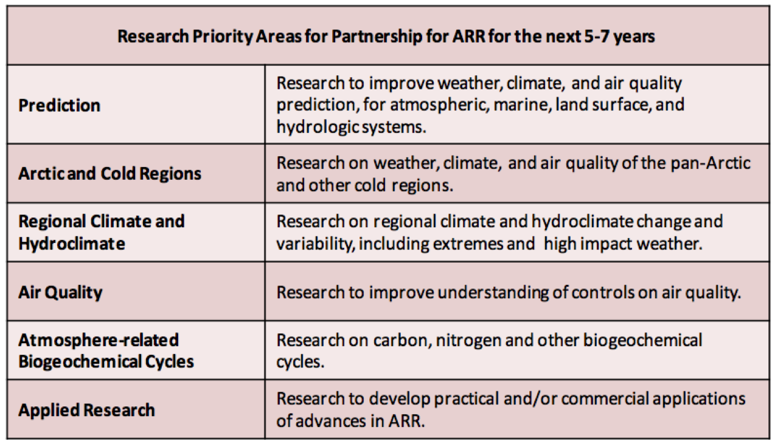

Table 1: Draft list of Research Priority Areas for Partnership for ARR for the 5-7 year timeframe.
Prediction: Research to improve weather, climate, and air quality prediction, for atmospheric, marine, land surface, and hydrologic systems, through enhanced use of ground- and space-based observations and improved process representation in models.
This Research Priority Area for Partnership concerns environmental prediction spanning a wide range of timescales – from less than an hour up to a few days, from daily to the subseasonal, from the subseasonal to the seasonal, and on to multiyear and multidecadal timescales – with a strong linkage to operational weather forecasting, climate prediction, and climate projection. Academic sector contributions to this area are strongly linked to government research and needs. This area brings together fundamental research involving observational, modelling, and theoretical activities. Such fundamental research is motivated by the need to improve prediction in the weather, climate, and air quality domains. This research responds to the needs of centers responsible for weather and climate prediction, as well as the needs of industry in this area. It is characteristically centered on the work of Canadian and international government research labs and to priorities of WWRP and WCRP. Work on data assimilation of atmospheric, oceanic, land surface, hydrologic, and cryospheric data; on instrument development and improving capacity and analysis of ground-based and space-based platforms and networks; on model development, testing and evaluation all figure into this area. Systems of interest broadly include atmospheric physical and chemical systems that extend from the surface through the whole atmosphere (including the troposphere, stratosphere, and upper atmosphere) and that are coupled to ocean, land, and sea ice systems. The context of global circulation and teleconnections, solar-terrestrial connections, investigations of past climate, and the influence of anthropogenic climate change on many aspects of environmental and climate prediction are also encompassed.
Arctic and Cold Regions: Research on weather, climate, and air quality of the pan-Arctic and other cold regions.
The Arctic occupies a place of singular scientific, socioeconomic, ecological, and geopolitical importance in Canada and globally. Societal and scientific interest in the Arctic, and cold regions more generally, is propelled by the signs of anthropogenic climate change that are imprinted so clearly there: rapid anthropogenic warming, moistening, ice retreat, and consequent socioeconomic and ecological impacts. Arctic and cold-region research in weather, climate, and air quality arguably cuts across all the other Research Priority Areas for Partnership in this White Paper and shares strong linkages to many research networks and fields of research outside the atmosphere-related domains identified in this White Paper. It is important, however, to assign a separate Priority Area to the Arctic and cold regions to reflect their distinctive character and importance in Canadian research. For example, Arctic field research is relatively expensive, requires long term investments and is logistically complex compared to field research at lower latitudes. A separate Research Priority Area also reflects current funding mechanisms such as NSERC’s Northern Research Supplement program. Areas covered by the Canadian ARR community include local measurements in the Arctic and cold regions; ground-based and space-based remote sensing of the Arctic atmosphere, snow, sea ice, and land ice; and modelling activities focused on Arctic and cold regions in the areas of weather, climate, air quality [e.g. stratosphere-troposphere circulation and ozone, and coupling to the Arctic land surface and marine environment (ocean, snow/ice, soil and vegetation ecosystems)].
Regional Climate and Hydroclimate: Research on regional climate and hydroclimate change and variability, including extremes and anticipated responses of high impact weather and hydrological systems to climate change, for inland, coastal and offshore regions.
This Research Priority Area for Partnership reflects Canada’s leadership in the area of hydroclimatic and environmental prediction on regional scales up to the continental (synoptic) scale. This involves ongoing regional model development and application activities in Canada; research on understanding past and present drivers and mechanisms of high impact weather events and hydroclimate extremes (droughts, floods); and related work on climate change impacts for industry and communities, e.g. the impacts of ocean acidification on ocean shelves and aquaculture. This Research Priority Area includes the interplay between regional analysis of global models and regional climate model work, and work in statistical and dynamical downscaling from global to regional scales. In this area there is an important role for field campaigns to validate process representation in models, including studies with a hydrological focus for land surface processes, and with a relatively fine-scale (1km-200km scale) weather process focus for atmospheric modelling. There are a number of emerging research tools useful for, among other applications, improving and testing climate models within this area, some of which include remote sensing from space and geochemical tracer technologies.
Air Quality: Research to improve understanding of controls on air quality.
This Research Priority Area for Partnership encompasses an extensive Canadian research community that conducts research into atmospheric composition and its relationship with management of air quality, with global climate change, with atmospheric visibility, with chemical production and loss that affect the flux of ultraviolet radiation, with atmospheric oxidation that breaks down pollution, as well as with human and ecosystem health. This research priority includes the complex range of processes affecting atmospheric composition, including interactions between trace gases, aerosols, clouds, and climate, from the surface to the middle atmosphere. Work in this area includes laboratory and field-based studies of atmospheric chemistry processes influencing atmospheric composition; land surface (hydrological and vegetation) systems influencing air quality; ground-based measurement networks and space-based remote sensing of parameters related to air quality and biogeochemical cycles (see next); modelling of processes affecting atmospheric composition, climate-chemistry interactions, etc. This area relates to applied domains including linkages between air quality and human health, and monitoring of atmospheric emissions arising from resource sector activities and forest fires.
Atmosphere-related biogeochemical cycles: Research on carbon, nitrogen, and other biogeochemical cycles.
This Research Priority Area for Partnership represents the multifaceted interconnections of ARR across the Earth system. Research examines how biogeochemical cycles influence atmospheric composition through exchange with the other reservoirs of the Earth system including the biosphere, hydrosphere, lithosphere, and cryosphere, in the past, present and future. Research investigates the natural sources and sinks of atmospheric carbon, nitrogen, sulfur, and other elements with implications for radiative forcing of climate, for fertilization of the marine and terrestrial biosphere, for cloud formation, and for acid deposition. Research considers the response of terrestrial vegetation (forests, grassland, wetland, etc.) and soil ecosystems to climate, land use, and atmospheric changes, and the feedbacks of these systems to the atmosphere. Research activities include field measurements across a range of environments; satellite and ground-based remote sensing; as well as modeling to test understanding of processes and to represent the state of knowledge needed to forecast future changes. The study of biogeochemical cycling connects the ARR community with other natural science communities across the Earth system.
Applied Research: Research to develop practical and/or commercial applications of advances in ARR, including weather and air-quality forecasting on a broad range of timescales, as well as applied research to address the impact of climate variability and anthropogenic climate change on human health, agriculture, and natural ecosystems on interannual and longer timescales.
The Research Priority Areas for Partnership above have the potential to lead to practical applications centred in the academic, government, and commercial sectors. Acknowledging this, we believe it is important to identify separately a focus on applied research leading to commercial and non-commercial applications. This area is intended to focus academic ARR on relevant domains of applied interest to industry and government over the next 5-7 years. This area includes applications, developed in part or in whole by university researchers, of short term (hourly to a few days), medium range (several days to subseasonal), and seasonal forecasting, as well as multi-year climate prediction. On shorter timescales, applied research could include weather and air-quality forecasting research for the renewable-energy and the resource extraction sector; for commerce, transportation and aerospace; for weather- and health-related hazards; for the financial sector; and for recreation and tourism. On multi-year timescales, academic ARR can bring to bear its research on seasonal-to-interannual timescale prediction for resource management, urban and regional planning, agricultural and health sector planning. This research also extends into long-term efforts in the area of airborne pollutant remediation and climate change adaptation for socio-economic and ecological (aquatic/forest) systems.
Activities in all these areas involve a mixture of research carried out entirely by members of the ARR community, as well as research requiring collaboration with other academic, government, and industrial groups within and outside academic ARR (e.g. oceanographers, agriculture and forestry scientists, engineers, economists, municipal and regional planners, etc.).

Strategic Planning through Consultation
We have defined our community’s scope (see Figure 1) and have proposed a list of six Research Priority Areas for Partnership (see Table 1). For university-based ARR to realize the two-way model of “Discovery to Application/Application to Discovery” requires effective partnership with government and industry. A key milestone in our strategic planning is to work with our partners to refine priorities across the sectors of academic, government, and industry (including non-governmental organization) research. A strategic plan that reflects well our partnership would satisfy our overarching goal of ensuring that ARR continue to best benefit all Canadians. It would help motivate suitably targeted funding calls, ensure that efforts to educate and train practitioners are effective, and make good use of data and infrastructure resources from the other sectors. This level of coordination would also help promote Canadian ARR at a high level on the international stage.
With this motivation we propose to establish (or, in some cases, renew) regular consultations with our partners in government and industry, starting with a series of workshops focused on developing a strategic plan. While the goals of such consultations are not detailed here, their main purpose would be to develop this Strategic Plan that covers, among other areas, the following elements:
- Research Priorities for Partnership over a 5-7 year (medium-term) period, referring to the list of six Research Priority Areas for Partnership in Table 1.
- Long-term planning of partnerships models for research support, including federal and provincial government research programs, non-governmental agency programs, industrial research programs, and other funding mechanisms. Many opportunities for improving our interactions were identified at the ARRCU workshop in Montreal in 2015, including reducing administrative barriers to partnership between government and academic scientists, relieving restrictive terms of partnership programs in some funding calls, enhancing the predictability and communication of funding opportunities, recognizing the need for support to maintain and enhance research infrastructure, and revisiting the balance between very large network support and support for small-team research projects. There was agreement that substantive input into the structure of future partnership programs from the academic ARR community will enhance the effectiveness of these programs.
- Long-term planning of partnership models for academic community use of research infrastructure and data, to ensure that Canadian scientists in all sectors are making the best use of publicly funded research resources with the overarching goal of improving Canada’s ARR outcomes and capacity to the benefit of all Canadians. Areas of improvement identified in our consultations include ensuring that Canadian academic and government scientists have suitable online access to data housed within each other’s research centres (enabled by easy to use online analysis tools), and that research infrastructure resources are coordinated effectively across the academic and government sectors.
- Medium and long term planning for education and training, to ensure that HQP in Canadian universities are being provided suitable education to succeed professionally in Canadian and international ARR and in related domains. This theme of education and training will be taken up in the next section.

Education, Training, Communications, and Outreach
About a quarter of the meeting time in our consultation workshops in 2014 and 2015 was devoted to discussions of the unique role of university-based ARR in education and training, as well as communication of our science and outreach to the public. A better organized academic ARR community could help coordinate these professional aspects in partnership with government and industry. It is clear that additional discussion of this critical area is required and several opportunities for specific improvements to Canada’s approach were identified. We outline some of the many good ideas that have been shared to this point, and propose to hold a separate consultation in these areas (see our recommendations below).
It has become clear that educational and training models for practitioners in weather forecasting, atmospheric science, and other ARR fields require renewal in the context of evolving pedagogical approaches, technology, and required skills for applied and fundamental research. There remains a need for classical core training in ARR science, technology, engineering and mathematics (STEM) foundations (applied mathematics, physics, chemistry, meteorology, oceanography, atmospheric chemistry, climatology, etc.). Such education allows students to, for example, develop intuition using simple models and examples to understand the mathematics, physics, and chemistry incorporated in state-of-the-art models and observational systems. But new approaches to disseminating this knowledge and more targeted forms of the curriculum should be considered. For example, at the 2015 workshop it was suggested that the ARRCU community could develop and promote online courses [following the UCAR Cooperative Operational Meteorological and Educational Training (COMET) model] to take advantage of expertise that is dispersed across different Canadian universities. A need to review the current offerings for professional meteorology programs in light of current hiring by government departments was raised. Academic and industry participants in our workshops emphasized the need for more practical training that is directly oriented towards the needs of the commercial sector, for example in areas of air-quality assessment, insurance, etc.
A recurring theme of our consultation has been that of communication and collaborative team-work skills. Regarding communications training, graduates from ARR discipline programs, as well as graduate students and postdoctoral researchers, will encounter greater professional success if they round out their analytical and computational competencies with strong communication skills. Such skills are also required to work in large-team projects that are increasingly common in our research and in industry.
But more broadly, we have heard from our partners that the ARRCU community needs to improve its communication and engagement with the public. To make the case for the continued relevance of ARR we will need to articulate our goals and priorities much more clearly to all audiences. These audiences include the general public, the media, colleagues outside ARR, university administrators and funding agencies, and our own students. We need to be more engaged with Canada’s media, taking advantage of our academic freedom to spark discussion on societally relevant issues related to weather, climate, and air quality research. We need to communicate our great work to prospective undergraduate and graduate students, who often know little about the rewarding range of careers possible in ARR. We need to better engage university administrations and funding agencies and governing bodies in science at the highest possible level, to better ensure coordination by the universities across the disciplinary areas represented in ARR (the C-CORU initiative provides a possible model for such an approach).

Conclusion: Academic Atmosphere-Related Research in a Changing Environment
This White Paper has identified a unique academic community of Canadian university researchers in the broad geoscience domain of ARR, which involves fundamental and applied research in weather, climate, and air quality. It has clarified the scope of our activities, and our connection to government- and industry-based ARR in Canada and internationally. We have also drafted an initial list of Research Priority Areas for Partnership that will provide a basis for subsequent planning with our partners in government and industry.
ARR in Canada would greatly benefit from coordinated planning that would include regular consultations and reviews of our research and educational activities. The 5-7 year window for planning would provide more predictability for this research but still permit us to respond to new challenges in a timely way. Such challenges could include, for example, the occurrence of an abrupt change in climate and related impacts, major technology changes or opportunities affecting the field, sudden fiscal challenges to the community, or the need for Canadian academic input into international environmental and climate assessment or regulatory protocols.
We conclude with some specific short-term actions and recommendations:
- Faculty in Canadian universities involved in ARR are encouraged to lend support to this White Paper by becoming signatories, by adding their names and affiliations to Table 2.
- This White Paper will be disseminated for comment to government departments in ARR, university administrations, industrial and commercial organizations engaged in using ARR, and NSERC.
- The ARRCU community seeks to partner with industry and government to develop a 5-7 year strategic plan for ARR. To support this, we propose and will be seeking funding support for a series of meetings: 1) a meeting between academic and government partners in ARR should take place in fall of 2016; 2) a subsequent meeting with industry partners for early 2017; 3) a subsequent meeting including all interested parties focused on education, training of highly qualified personnel, communications and outreach in the ARR domains should be scheduled for later in 2017.
- As some current planning for ARR is currently ongoing, it is important that representatives of academic ARR be involved in coming discussions, particularly for NSERC Partnership program planning.
- Because ARRCU scientists can be found in many disciplines and across many university departments, we will promote this White Paper to various learned societies in Canada (including CMOS, CGU, CSC, CAP, CMS, CASI, etc.) and internationally (AMS, AGU, EGU, etc.).

Table 2: Canadian University Faculty in ARR Signatory to this White Paper
Name | Affiliation
- Kushner, Paul | University of Toronto
- Gauthier, Pierre | Université de Québec à Montréal
- Gyakum, John | McGill University
- Martin, Randall | Dalhousie University
- Monahan, Adam | University of Victoria
- Myers, Paul | University of Alberta
- Strong, Kimberly | University of Toronto
- Stull, Roland | University of British Columbia
- Taylor, Peter | York University
- Abbatt, Jonathan | University of Toronto
- Al-Abadleh, Hind | Wilfred Laurier University
- Araif, Altain | McMaster University
- Bertram, Allan | University of British Columbia
- Bourassa, Adam | University of Saskatchewan
- Bush, Andrew | University of Alberta
- Chan, Arthur | University of Toronto
- Chang, Rachel | Dalhousie University
- Chen, Jing | University of Toronto
- Degenstein, Doug | University of Saskatchewan
- Déry, Stephen | University of Northern British Columbia
- Drummond, James | Dalhousie University
- Fletcher, Chris | University of Waterloo
- Folkins, Ian | Dalhousie University
- Gachon, Phillipe | Université de Québec à Montréal
- Jackson, Peter | University of Northern British Columbia
- Jasechko, Scott | University of Calgary
- Kohfeld, Karen | Simon Fraser University
- Laprise, René | Université de Québec à Montréal
- Manson, Alan | University of Saskatchewan
- Marshall, Shawn | University of Calgary
- Merlis, Timothy | McGill University
- Norman, Ann-Lise | University of Calgary
- Predoi-Cross, Adriana | University of Lethbridge
- Saari, Rebecca | University of Waterloo
- Sica, Robert | Western University
- Swaters, Gordon | University of Alberta
- Sushama, Laxmi | Université de Québec à Montréal
- Sutherland, Bruce | University of Alberta
- Wiacek, Aldona | St. Mary’s University
- Wilson, John D. | University of Alberta
- Zwiers, Francis | University of Victoria

Address comments and correspondence to:
- Paul Kushner (ARRCU-WG Committee Chair) <paul.kushner@utoronto.ca>
- Pierre Gauthier <gauthier.pierre@uqam.ca>
- John Gyakum <john.gyakum@mcgill.ca>
- Randall Martin <randall.vaughn.martin@gmail.com>
- Adam Monahan <monahana@uvic.ca>
- Paul Myers <pmyers@ualberta.ca>
- Kimberly Strong <strong@atmosp.physics.utoronto.ca>
- Roland Stull <rstull@eos.ubc.ca>
- Peter Taylor <pat@yorku.ca>
- Bob Christensen (admin support) <bob.christensen@utoronto.ca>

