A White Paper on Atmosphere-Related Research in Canadian Universities (ARRCU)
ARRCU Working Group Committee: P. Kushner (chair), P. Gauthier, J. Gyakum, A. Monahan, P. Myers, K. Strong, R. Stull, P. Taylor
Contents
Section | Page
Abstract and Introduction | 1
ARRCU: Definition, Scope and Objectives | 3
Building Capacity and Excellence in ARR | 5
Research Priorities | 8
Strategic Planning through Consultation | 11
Education, Training, Communications, and Outreach | 12
Conclusion: Academic ARR in a Changing Environment | 13

Abstract
This White Paper describes a community of Canadian University scientists who carry out research on weather, climate, and air quality. Atmosphere-related research (ARR) is an integrative enterprise involving observational, theoretical, and modelling approaches and is characterized by strong linkages between fundamental and applied research. A strategic planning initiative is proposed whose overarching goal is to ensure that academic ARR is configured so as to most benefit Canada in light of rapid societal, economic, and environmental change. In this initiative ARR practitioners from Universities, government and industry develop a strategic plan that will be periodically revisited on a five-to-seven year timeframe. The purpose of this strategic plan is to clarify research and related resource priorities, partnership arrangements, and priorities related to education and training for Canadian ARR. The White Paper lays out a draft list of ARR priorities focused on 1) weather and climate prediction; 2) the Arctic and cold regions; 3) regional climate, extremes, and weather and climate impacts; 4) air quality and carbon cycle research; and 5) applications of ARR. It then proposes next steps required to put the strategic planning process into effect.
Introduction
We Canadians depend in our work and our leisure on high quality scientific information about weather, climate, and air quality. Severe weather and marine forecasts, long-term temperature and precipitation assessments, air pollution outlooks, and many other related products and services help us plan everyday activities, make informed business decisions, and develop effective infrastructure designs for our communities. Beyond this, we are inspired and concerned by issues surrounding weather, climate and air quality. We turn to scientific experts in these areas to help us understand extreme events (such as the great Québec ice storm of 1998, 2012's Superstorm Sandy and other hurricanes that impact Atlantic Canada each year, the 2013 Calgary flood, and severe urban air pollution events), variations and changes in climate (such as the effects of El Niño on our weather, human-caused global warming and Arctic sea-ice loss), and related impacts (on recent forest fires in the West and the Prairies, on public health, on agriculture, etc.). All in all, a strong business case, and a strong case in terms of value to society, can be made that investments to support these services and expertise are worthwhile.
Recognizing this, Canada and other industrialized countries have invested in a global ‘knowledge resource’ in weather, climate, and air quality that is easily available to private citizens and institutions. This resource is supported by more than a century of research by dedicated scientists in many professional settings including academia, government, and industry. This research, along with major investments in measurement systems and computer resources, have over the years greatly improved our observing and forecasting tools in weather, climate and air quality; these in turn have led to economic payoffs that enhance our prosperity. Much of this research involves ‘big science’ on a national and international scale; it coordinates large groups of researchers who study how local weather, climate, and air quality conditions ‘here at home’ are linked to global conditions ‘everywhere else’. But often the frontier of this research involves innovation by individual scientists, working on new ideas in laboratories and small research groups, exploring scientific fundamentals, and discovering new ways to make this knowledge relevant to people and communities across Canada and around the world.
The authors and signatories to this White Paper form a group of Canadian University scientists who care passionately about the state and fate of Canada's research in weather, climate, and air quality. The purpose of this White Paper is to synthesize a vision of our research community's plans and priorities in the coming years. It is time to tackle challenging questions such as Where should our research go next? How can University researchers (academics) better work with our government and industry partners? How do we educate the next generation of students and practitioners? We are addressing these questions in a period of evolving partnerships between University, government, and industry; of changing expectations for research funding; and of transformation in University education. Besides these general trends, in our fields of research in Canada, an important government-University partnership in this area, the Climate Change and Atmospheric Research (CCAR) program of Canada's Natural Sciences and Engineering and Research Council (NSERC), is past its half-way point and is being reviewed. We are asking, and are being asked, if the CCAR approach would be a good one to try again with new resources. To answer such questions, we need to put time and effort now into strategic planning for our fields of research in Canada.
In this White Paper we will outline the perspective that our community, ‘Atmosphere-Related Research in Canadian Universities’ (ARRCU), has put forward to develop a strategic plan in weather, climate, and air quality research. The work leading to this White Paper started with a 2014 Montréal workshop hosted by the U.S.-based University Corporation for Atmospheric Research and culminated in a 2015 workshop sponsored by NSERC and other organizations. (Some background information, gathered for the 2015 ARRCU workshop, is available at http://tinyurl.com/arrcu-may2015-workshop and a workshop report can be found at http://tinyurl.com/arrcu-CMOS-Bull-2016.) The authors of this White Paper are the ARRCU working group's organizing committee; we have had input from many others, and those who have signed onto the White Paper (see Table 1) support the viewpoint it outlines. It will take time and work with our partners to produce a detailed strategic plan in Atmosphere Related Research (ARR) in Canada. But each step along this path has been stimulating and we are confident that this effort will lead to improved organization, clarity, and focus of our work.
Next we will define the aims of the ARRCU community and outline directions for our priorities in the coming years. We want the key messages of this White Paper to be understood by our partners in government and industry, our University administrators and colleagues in other fields, our colleagues around the world, and the general public. We appreciate any feedback you, the reader, can share with us to help make our message clear and straightforward (please send comments to Paul Kushner at paul.kushner@utoronto.ca).

Atmosphere-Related Research in Canadian Universities: Definition, Scope and Objectives
The ARRCU community is a group of researchers in Canadian Universities working on fundamental and applied scientific research in weather, climate, and air quality. Many of us focus our research on the atmosphere, which is the natural system that supplies the environment for the air we breathe and the weather events and climate conditions we experience. But the atmosphere cannot be studied in isolation. So included in our group are many others who study natural systems connected to the atmosphere, such as the oceans, systems related to the land surface such as forests and soils, and frozen systems such as sea ice (especially relevant to Canadians). We research the physical, biological, and chemical processes controlling and connecting these natural systems – a technical term to describe many of these coupled processes is biogeochemical. Our science draws on advanced mathematics and statistics, cutting edge laboratory facilities, networked ground- and space-based observations, coordinated field observation campaigns, and numerical model simulations carried out on high performance computers. Given the many natural systems, processes and techniques involved, research in weather, climate, and air quality, which we call atmosphere-related research (ARR), needs to coordinate many elements to be done well. Terms we can use to describe this kind of research are integrative, interdisciplinary, and multidisciplinary. The green shaded table in Schematic 1 summarizes the definition of ARR.
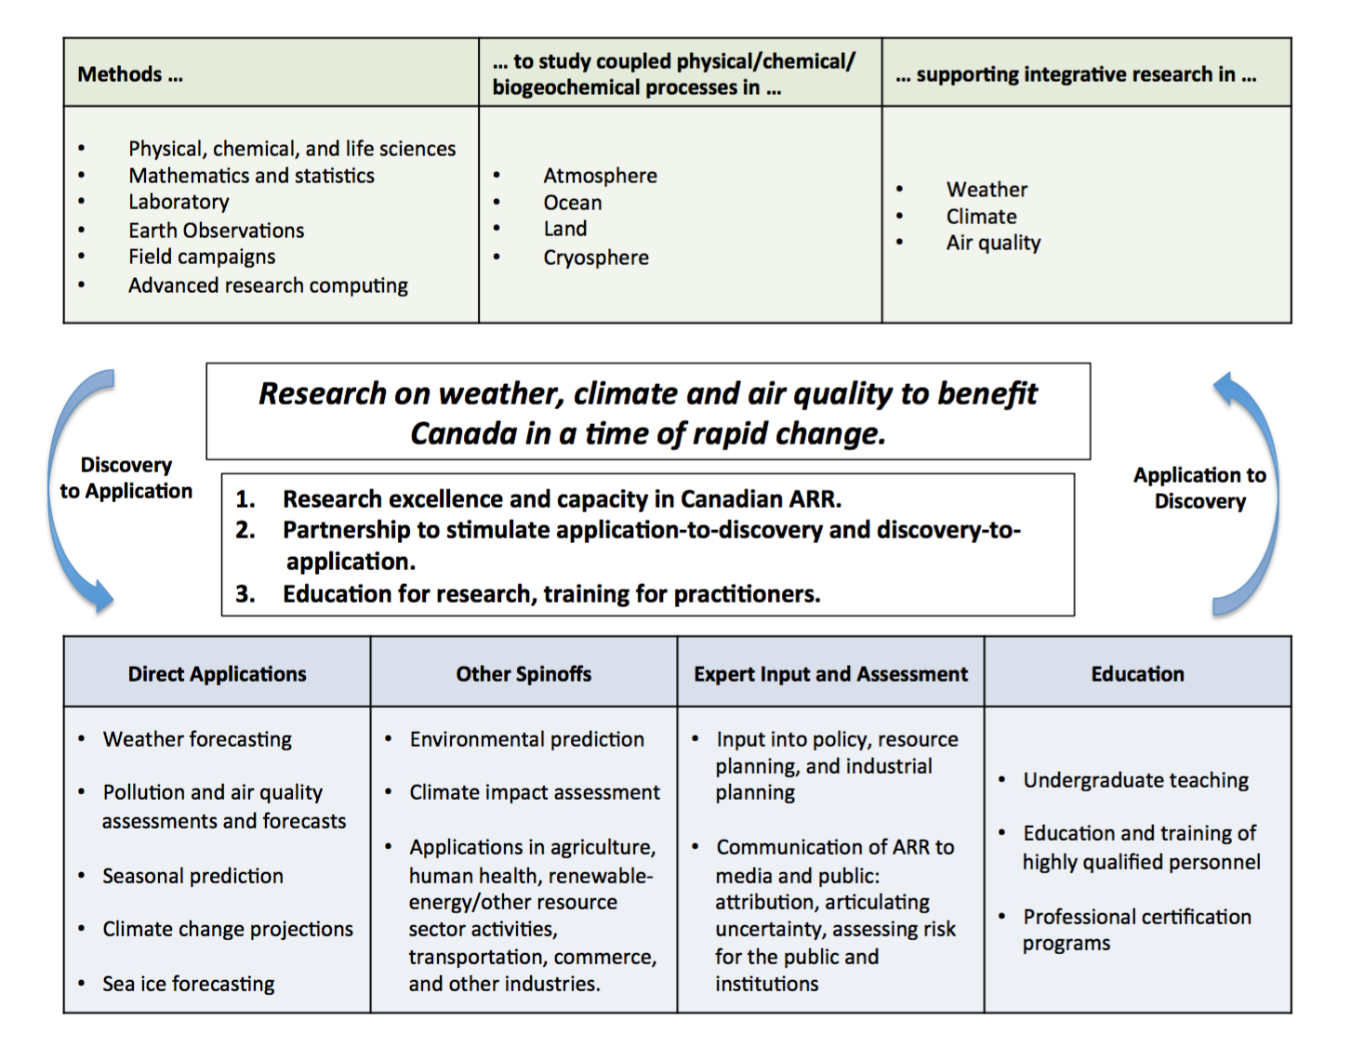
Schematic 1: Scope and framework for University-based Atmosphere-Related Research (ARR)
The blue shaded table in Schematic 1 summarizes various applications, including products, services, and professional roles that are informed by academic ARR. Daily forecasts of weather, outlooks of pollutant distribution, and prediction of seasonal climate, come directly from observations and computer models of the atmosphere, oceans, etc.. While these are typically produced by government departments such as Environment and Climate Change Canada (ECCC), and used by individuals and industry, University-based research continually contributes to improving these products. A wide range of spinoff products, developed inside and outside universities, add value to these tools; these are used for economic and environmental prediction for industry, agriculture, human health, renewable energy and other resource sector activities, transportation, commerce, and other industries. As for our government and industry colleagues, many University-based researchers in ARR lend scientific expertise to policy development, resource planning, and industrial planning in Canada and around the globe. We also work to communicate our research to institutions and the public, and share our scientific expertise on weather, climate, and air quality. Finally, an important role for us, particularly in the Universities, is in post-secondary education, training students and other highly qualified personnel (HQP) in research, forecasting practice, and other areas.
Weather forecasts and the related products and services we have been discussing are so easily available that they can be taken for granted. Canadians today are benefitting from several decades of investments in ARR, but ongoing financial investments and coordinated effort are needed to ensure that Canadians will continue to receive the benefits that advancement of ARR can bring. Academic researchers have long pointed out that investments in fundamental and applied ARR have a proven track record of leading to valuable applications. But more recently, we have sought to engage and listen to our partners in private companies, government laboratories and forecast centres to stimulate key directions for fundamental research. The arrows in the schematic highlight a two-way connection, from discovery to application and from application to discovery. As scientists engaged in fundamental research, we believe that curiosity-driven research is an effective path towards new discoveries with practical spinoffs. Conversely, in this period of exciting opportunities, we seek ways to enhance our ability to effectively address the needs of our partners. This back and forth between fundamental and applied research is also relevant to the changing educational mission of our University institutions. We are being challenged to address the practical needs of students, discover entrepreneurial opportunities, talk to the industries that hire our graduates, and adapt our methods and academic programs accordingly.
The products and services in Schematic 1 involve considerable interaction between R&D activities in the three domains of academia, government, and industry. Such interactions also extend to so-called non-governmental organizations that are active in ARR and development of related spinoff products. This professional interaction across different sectors is an important part of what we mean by partnership. Partnership with government and industry is one of the main ways Universities have obtained resources for ARR and its supporting infrastructure including lab, computing, and field measurement resources. The University community in ARR needs to be organized to respond as these partnerships evolve.
We have now introduced the ARRCU community and outlined some of our roles and challenges in research, education, and partnerships. With this perspective, the purpose of the ARRCU community’s planning initiative can be stated as follows:

The overarching goal of the ARRCU community’s planning initiative is to ensure that Canadian University-based research in weather, climate, and air quality, which we call atmosphere-related research (ARR), is configured to most benefit Canadians as our nation undergoes rapid societal, economic, and environmental change.

To support this overarching goal the academic community in ARR should endeavour
- To build capacity and excellence in Canadian University-based ARR. This means creating conditions for innovative fundamental and applied research on atmospheric, marine, terrestrial and cryospheric systems that we have grouped under the ARR rubric;
- To develop sustainable models of support for Canadian University-based ARR and effective strategic partnership between the academic, government, and industry sectors; and
- To educate future researchers, train practitioners, and provide expertise to our partners and the public in research related to weather, climate, and air quality.
In the rest of the White Paper, we will discuss each of these priory areas in turn, and then summarize some key recommendations for a strategic plan in ARR. We reiterate that a full strategic plan for ARR in Canada requires more consultation with our government and industry partners. Even so, the ideas in this White Paper will provide the University-based ARR community’s perspective for strategic planning with our partners.
Building Capacity and Excellence in ARR
If we want our strategic plan to maintain and enhance Canada's excellence in ARR, we need to recognize the integrative nature of ARR, and to identify and regularly update our research priorities. We need to pay attention to the broader field of international ARR, but also work in the Canadian context, focusing on areas Canada can best contribute to.
What exactly do we mean by integrative? Fundamental ARR considers simultaneously many different natural systems (atmosphere, ocean, land surface, etc.) and requires many different scientific approaches (observations, models, theory). In ARR, coordinated field observations from ground-based, space-based, airborne and shipborne measurement platforms complement careful laboratory investigations in controlled environments. Comprehensive computer models (such as those used in weather and seasonal prediction systems, marine environmental forecasting, climate analysis, pollution assessment, and so on) sum up our current knowledge of physics, chemistry, biogeochemistry of the processes that govern weather, climate, and air quality and are complemented by process models that study phenomena in isolation. Observational data stimulates new theory and model development, and provides input parameters and ground truth for our models. Data assimilation systems integrate all this information obtained from model and observations into 'analyses', our best estimate of the state of the atmosphere and the systems it is connected to. These state estimates provide input to daily weather forecasts, seasonal and longer timescale climate predictions, and estimates of sources of greenhouse gas and other pollutants. Blending observation and models through data assimilation improves our prediction systems through insights into the processes controlling weather, climate, and air quality. These insights in turn inspire new observational efforts. Scientific advances in observations and modelling require research on fundamental theoretical principles in mathematics, physics, chemistry, computer science, geoscience, geography, biology, ecology, etc.. Well-integrated ARR allows a focused observation or process study in an apparently specialized area to lend insight into many areas. A study of airflow around cloud droplets leads to insights for models of atmospheric convection, which can improve weather and climate forecasts. Studying how pollution is transported gives insight into the chemical reactions involved, and learning about this chemistry can help us understand atmospheric winds and circulations. Intensive observation of snow and hydrological processes in cold climates at carefully chosen field sites in Canada's boreal forests can help us understand energy and water exchanges in similar forests around the world, and improve our ability to model the land surface for climate analysis.
Applications of ARR also span a huge range and similarly integrate many areas of applied and social science research. ARR applied research includes forecasting and environmental prediction, and research relevant to human health, agriculture, land and water resource management, renewable energy, climate change adaptation and impact evaluation. We need to articulate potential direct payoffs of ARR: for example, funding from NSERC, Environment and Climate Change Canada (ECCC), Health Canada and the use of NASA satellites enabled a study on a Canada-wide assessment of exposure to fine airborne particulates (PM2.5), providing potentially tens of billions of dollars in health benefits. As another example, research on atmospheric chemistry in the Arctic contributed to the understanding of the emergence of the ozone hole which in turn led to an international agreement, the Montréal Protocol, to address this very critical societal problem. Our strategic plan needs to emphasize the linkage between fundamental and applied science. We need to make a strong case that for ARR to continue to provide significant benefits in the health, agricultural, economic, ecological and other domains, investment in large-scale infrastructure such as satellites, field programs, and high performance computing are required.
As a result of its multidisciplinary nature, ARR can happen in many science and social science departments across any given university. Our strategic plan will help the ARRCU community communicate to University leadership how ARR integrates across departmental and institutional boundaries. Communicating this will also help us recruit top students and professional talent to sustain excellence in Canadian ARR.
Framing Research Priorities
Considering international practice and the example of other scientific communities in Canada, a strategic plan for ARR should identify fundamental and applied research priorities that should be regularly updated. We propose here that such plans could be revised every five to seven years, with the precise renewal period remaining to be determined. To our knowledge, no such planning process involving our partners across the research areas the ARRCU community includes has been undertaken in Canada. Fortunately, we may refer to several Canadian and international planning processes to help frame our ideas.
Our strategic plan for weather, climate, and air quality science in Canada needs to reflect global connections in the natural world and in the socio-economic context. A natural focus of Canadian ARR should be Canada's land mass, its coastal zone, and its Arctic territory. Improvements in forecasting and assessment and the development of value-added spinoffs directly relate to the concerns and needs of Canadian citizens and communities, as well as Canadian government and industry. But we need to communicate that, in many ways, ARR crosses geographic and national boundaries. Fundamental ARR is concerned with processes that take place in natural systems, such as cloud and precipitation systems, lake systems, and cold region systems, that can be found in midlatitude and high-latitude regions worldwide. Furthermore, we know that atmospheric, oceanic, land surface, and sea ice conditions in remote regions have a strong influence on Canada's territory through atmosphere-ocean teleconnections and global atmosphere-ocean circulations. Finally, it is in Canada's strategic interest to maintain significant expertise in weather, climate, and air quality issues that extend past Canada’s borders but are relevant to Canada’s economy and society, e.g. international contributions to emissions affecting air quality and atmospheric trace gas composition (carbon dioxide, ozone, etc.).
Global linkages are well reflected in international research programs that provide high level structure for our research; the ARRCU community can readily turn to these programs for guidance. For example, the World Meteorological Organization's (WMO) programs such as the World Weather Research Program and World Climate Research Program (WWRP and WCRP), as well as the Future Earth program [which has incorporated several programs connected to ARR formerly under the International Geosphere-Biosphere Program (IGBP)], provide useful practical frameworks for research planning that can be adapted to the Canadian context. Many of these programs include considerable Canadian input in their development. Another planning framework in the Canadian context is provided by the NSERC Climate Change and Atmospheric Research Program (CCAR), which called for research in key theme areas of ARR. To summarize some aspects of these international and national programs relevant to this discussion:
- The WWRP focuses on research to improve weather prediction. Its primary research priorities are organized around projects on high impact weather (with the acronym HIW), polar prediction (PPP), and subseasonal to seasonal prediction (S2S, joint with the WCRP).
- The WCRP's research focus is on climate predictability and human influence on climate. Its core programs are on cryosphere and climate (ClIC), climate predictability and variability (CLIVAR), hydrological cycles involving atmosphere and the Earth's surface (GEWEX), and stratospheric processes (SPARC). It has recently identified cross-cutting ‘Grand Challenges’ intended to draw together research across these projects, including ‘Clouds, Circulation, and Climate Sensitivity’, ‘Melting Ice and Global Consequences’, ‘Climate Extremes’, etc.. These Grand Challenges use questions (e.g. How will clouds and circulation respond to global warming or other forcings?) and storylines to stimulate public interest in the research.
- The Future Earth Program encompasses a broad program of research in Earth System Science organized on the theme of sustainability. Programs closely related to ARR include the International Global Atmospheric Chemistry program (IGAC) which coordinates and develops the scientific community via large, international projects; the Surface Ocean and Lower Atmosphere Study (SOLAS) that integrates aspects of the coupled biogeochemistry of the oceans and atmosphere; and the Integrated Land Ecosystem-Atmosphere Processes Study (iLEAPS), which focuses on the coupled biogeochemistry of the land surface, terrestrial biosphere, and atmosphere, with an emphasis on human influences in these processes.
- The Canadian Consortium of Ocean Research Universities (C-CORU) has sought since 2011 to coordinate ocean science research across several Canadian universities, and provides a useful point of reference for our efforts in ARR.
- The Canadian CCAR program identified three research areas that supported research priorities of the Government of Canada in the 2012-2018 time period: 1) Understanding Earth system processes and their representation in weather, climate and atmospheric chemistry models, 2) Advancing weather, climate and environmental prediction, and 3) Understanding recent changes in the Arctic and cold region environments.
Within these broad programmatic structures, our strategic plan needs to also recognize that Canada, as a prosperous country featuring a relatively small and geographically dispersed population, should carefully focus its research resources. This requires identifying critical research gaps that can capitalize on Canada’s infrastructural and institutional strengths, as well as its unique historical and geographical context.
With this background, we propose that our strategic plan should identify a handful of priorities areas that integrate across research areas (similarly to the structure of WCRP and CCAR program elements), that reflect Canada's core strength and expertise, and that will naturally align with our partner's priorities.
Research Priorities
The following five Research Priorities (tabulated in Schematic 2) are offered as the University ARR community’s starting perspective, based on the consultations that took place in 2015, for Research Priorities that might appear in a Strategic Plan for ARR involving academic, government, and industry. These priorities are expected to evolve as our strategic planning process continues. These proposed priority areas reflect some of those mentioned above in connection with the CCAR, WCRP, WWRP, and Future Earth programs.
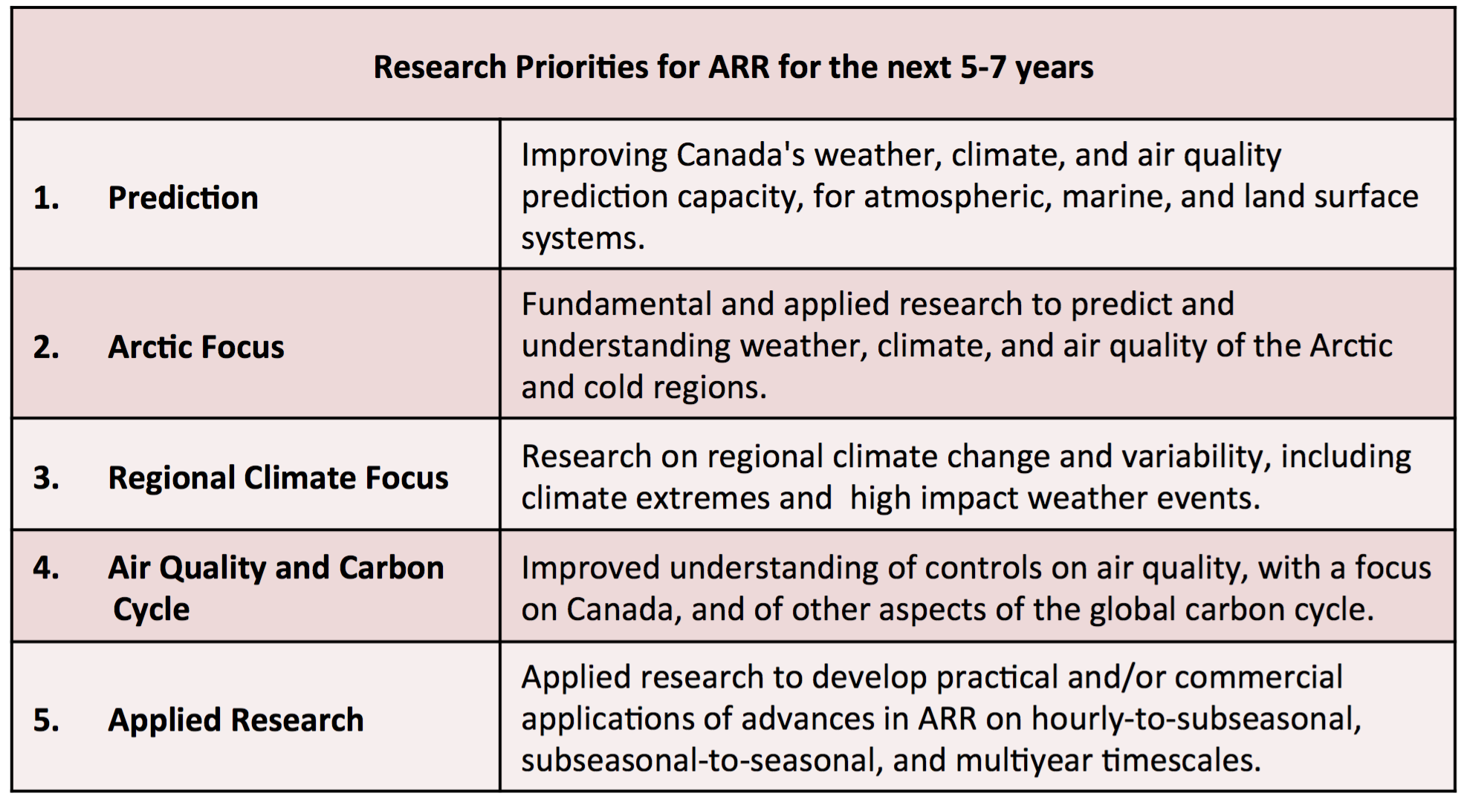Schematic 2: Draft list of ARR Priorities for the 5-7 year timeframe.
Research Priority 1 – Prediction: Improving Canada's weather, climate, and air quality prediction capacity, for atmospheric, marine, and land surface systems, through enhanced use of ground- and space-based observations and improved process representation in models.
This research area includes environmental prediction research on hourly-to-subseasonal, subseasonal-to-seasonal, and multiyear timescales with a strong linkage to weather forecasting, climate prediction, and operational applications. This research area brings together fundamental research involving observational, modelling, and theoretical activities. Under this Research Priority, such fundamental research is motivated by the need to improve Canada’s capacity for prediction in the weather, climate, and air quality domains. This research responds to the needs of Canadian government laboratories responsible for weather and climate prediction, as well as the needs of industry in this area. It is linked to international priorities embodied in priorities of WWRP and WCRP. Work on data assimilation of atmospheric, oceanic, land surface, and cryospheric data; on improving capacity and analysis of ground-based and space-based platforms and networks; on model development, testing and evaluation all figure into this Research Priority. Systems of interest broadly include atmospheric physical and chemical systems that extend from the surface to the whole atmosphere and that are coupled to ocean, land, and sea ice systems. The context of global circulation and teleconnections, investigations of past climate, and the influence of anthropogenic climate change on many aspects of environmental and climate prediction are also encompassed.
Research Priority 2 – Arctic Focus: Fundamental and applied research to predict and understand weather, climate, and air quality of the pan-Arctic and other cold regions in Canada.
The Arctic occupies a place of singular scientific, socioeconomic, ecological, and geopolitical importance in Canada. Societal and scientific interest in the Arctic is propelled by the signs of anthropogenic climate change that are imprinted so clearly there: rapid anthropogenic warming, moistening, ice retreat, and consequent socioeconomic and ecological impacts. Arctic research in weather, climate, and air quality arguably cuts across all the other Research Priorities in this White Paper and shares strong linkages to many research networks and fields of research outside the atmosphere-related domains identified in this White Paper. It is important, however, to assign a separate Research Priority to the Arctic to reflect its distinctive character and importance in Canadian research. Arctic field research is relatively expensive and logistically complex compared to field research at lower latitudes, and Canada’s Arctic research expertise is internationally recognized. A separate research priority also reflects current funding mechanisms such as NSERC’s Northern Research Supplement program. Areas covered by the Canadian ARR community include ground-based and space-based measurement and remote sensing for the Arctic region and the Arctic atmosphere; and modelling activities focused on Arctic weather, climate, air quality, including coupling to the Arctic land and marine surface (ocean, sea and land ice, soil and vegetation systems).
Research Priority 3 – Regional Climate Focus: Research on regional climate change and variability, including climate extremes and anticipated responses of high impact weather and hydrological systems to anthropogenic climate change, for all inland and coastal regions in Canada.
This Research Priority reflects Canada’s ongoing leadership in the area of climate and environmental prediction on regional scales up to the continental (synoptic) scale. This involves ongoing regional model development and application activities in Canada; research on understanding drivers and mechanisms of high impact weather events and hydroclimate extremes (droughts, floods); and related work on climate change impacts for industry and communities. This Research Priority includes the interplay between regional analysis of global models and regional climate model work in Canada, and work in statistical and dynamical downscaling from global climate to regional scales. In this Research Priority there is an important role for field campaigns to validate process representation in climate models, including studies with a hydrological focus for land surface processes, and with a mesoscale (10-200 km scale) weather process focus for atmospheric modelling. Within this Research Priority, Earth observations from space also play a significant role through, for example, land surface remote sensing.
Research Priority 4 – Air Quality and Carbon Cycle Research: Improved understanding of controls on air quality, with a focus on Canada, and of other aspects of global carbon cycle and other biogeochemical cycles that interact with climate.
Research Priority 4 includes research into air pollution and its relationship to global anthropogenic climate change, regional and global carbon balances, other biogeochemical cycles in atmospheric and marine systems, and interactions of the atmosphere with global terrestrial and marine biogeochemical cycles. Work in this area includes laboratory and field-based studies of atmospheric chemistry processes influencing pollution and atmospheric composition; land surface (hydrological and vegetation) systems involved in the carbon cycle; ground-based measurement networks and space-based remote sensing of parameters related to air quality and biogeochemical cycles; modelling of pollutant transport and climate-chemistry interactions, etc. This Research Priority relates to applied domains including linkages between air quality and human health, and monitoring of atmospheric emissions arising from resource sector activities.
Research Priority 5 – Practical Applications: Applied research to develop practical and/or commercial applications of advances in ARR on two different timescales: 1) forecasting weather on hourly, to subseasonal, to seasonal timescales; and 2) applied research to address the impact of climate variability and anthropogenic climate change on human health, agriculture, and natural ecosystems on interannual and longer timescales.
Research Priority 5 is intended to focus academic ARR on relevant domains of practical interest to industry and government over the next 5-7 years. This Research Priority includes applications, developed in part or in whole by University researchers, of hourly, to subseasonal, and to seasonal timescale forecasting and multi-year climate prediction. On shorter timescales, applied research could include weather forecasting research for the renewable-energy and the resource extraction sector; for commerce and transportation; for weather-related hazards; for the financial sector; and for recreation and tourism. On multi-year timescales, academic ARR can bring to bear its research on seasonal-to-interannual timescale prediction for resource management, urban and regional planning, agricultural and health sector planning. This research also extends into the domain of climate change adaptation research for socio-economic and ecological (aquatic/forest) systems.
Activities in all of these research priority areas will involve a mixture of research carried out entirely by members of the ARR community, as well as research requiring collaboration with other academic, government, and industrial groups within and outside academic ARR (e.g. oceanographers, agriculture and forestry scientists, engineers, economists, municipal and regional planners, etc.).

Strategic Planning through Consultation
We have defined our community’s scope (see Schematic 1) and have proposed a list of five research priorities (see Schematic 2). For University-based ARR to realize the two-way model of “Discovery to Application/Application to Discovery” requires effective partnership with government and industry. A key milestone in our strategic planning is to finalize the list of research priorities for planning across the sectors of academic, government, and industry (including non-governmental organization) research. A strategic plan that reflects well our partnership would satisfy our overarching goal of ensuring that ARR continue to best benefit all Canadians. It would help motivate suitably targeted funding calls, ensure that efforts to educate and train practitioners are effective, and make good use of data and infrastructure resources from the other sectors. This level of coordination would also help promote Canadian ARR at a high level on the international stage.
With this motivation we propose to establish (or, in some cases, renew) regular consultations with our partners in government and industry, starting with a series of workshops focused on developing a strategic plan. To our knowledge, it has been several years since Canada’s academic ARR community has been involved in regular consultations with its partners.
While the goals of such consultations are not detailed here, their main purpose would be to develop this Strategic Plan that covers, among other areas, the following elements:
- Research priorities over a 5-7 year (medium-term) period, using the list of five research priorities in Schematic 2 as the ARRCU community’s initial position.
- Long-term planning of partnerships models for research support, including federal and provincial government research programs, non-governmental agency programs, industrial research programs, and other funding mechanisms. Many opportunities for improving our interactions were identified at the ARRCU workshop in Montreal in 2015, including reducing administrative barriers to partnership between government and academic scientists, relieving restrictive terms of partnership programs in some funding calls, enhancing the predictability and communication of funding opportunities, recognizing the need for support to maintain and enhance research infrastructure, and revisiting the balance between very large network support and support for small-team research projects. There was agreement that substantive input into the structure of future partnership programs from the academic ARR community will enhance the effectiveness of these programs.
- Long-term planning of partnership models for academic community use of research infrastructure and data, to ensure that Canadian scientists in all sectors are making the best use of publicly funded research resources with the overarching goal of improving Canada’s ARR outcomes and capacity to the benefit of all Canadians. Areas of improvement identified in our consultations include ensuring that Canadian academic and government scientists have suitable access to data housed within each other’s research centres, and that research infrastructure resources are coordinated effectively across the academic and government sectors.
- Medium and long term planning for education and training, to ensure that HQP in Canadian Universities are being provided suitable education to succeed professionally in Canadian and international ARR and in related domains. This theme of education and training will be taken up in the next section.

Education, Training, Communications, and Outreach
About a quarter of the meeting time in our consultation workshops in 2014 and 2015 was devoted to discussions of the unique role of University-based ARR in education and training, as well as communication of our science and outreach to the public. A better organized academic ARR community could help coordinate these professional aspects in partnership with government and industry. It is clear that additional discussion of this critical area is required and several opportunities for specific improvements to Canada’s approach were identified. We outline some of the many good ideas that have been shared to this point, and propose to hold a separate consultation in these areas (see our recommendations below).
It has become clear that educational and training models for practitioners in weather forecasting, atmospheric science, and other ARR fields require renewal in the context of evolving pedagogical approaches, technology, and required skills for applied and fundamental research. There remains a need for classical core training in ARR foundations (mathematics, physics, chemistry, meteorology, oceanography, atmospheric chemistry, climatology etc.). Such education allows students to, for example, develop intuition using simple models and examples to understand the mathematics, physics, and chemistry incorporated in state-of-the-art models and observational systems. But new approaches to disseminating this knowledge and more targeted forms of the curriculum should be considered. For example, at the 2015 workshop it was suggested that the ARRCU community could develop and promote online courses [following the UCAR Cooperative Operational Meteorological and Educational Training (COMET) model] to take advantage of expertise that is dispersed across different Canadian universities. A need to review the current offerings for professional meteorology programs in light of current hiring by government departments was raised. Academic and industry participants in our workshops emphasized the need for more practical training in meteorology and oceanography that is directly oriented towards the needs of the commercial sector, for example in areas of air-quality assessment, insurance, etc..
A recurring theme of our consultation has been that of communication and collaborative team-work skills. Regarding communications training, graduates from ARR discipline programs, as well as graduate students and postdoctoral researchers, will encounter greater professional success if they round out their analytical and computational competencies with strong communication skills. Such skills are also required to work in the kind of large-team projects that are increasingly common in our research and in industry.
But more broadly, we have heard from our partners that the ARRCU community needs to improve its communication and engagement with the public. Once we agree on our research priorities, to make the case for the continued relevance of ARR we will need to much more clearly articulate these priorities to all audiences. These audiences include the general public, the media, colleagues outside ARR, University administrators and funding agencies, and our own students. We need to be more engaged with Canada’s media, taking advantage of our academic freedom to spark discussion on societally relevant issues related to weather, climate, air quality research. We need to communicate our great work to prospective undergraduate and graduate students, who often know little about the rewarding range of careers possible in ARR. We need to better engage University administrations and funding agencies and governing bodies in science at the highest possible level, to better ensure coordination by the Universities across the disciplinary areas represented in ARR (the C-CORU initiative provides a possible model for such an approach).
Conclusion: Academic Atmosphere-Related Research in a Changing Environment
This White Paper has identified a unique academic community of Canadian University researchers in a broad area of geoscience research we have termed Atmosphere-Related Research (ARR) focused on fundamental and applied research in weather, climate, and air quality. It has clarified the scope of our activities, and our connection to government and industry based ARR in Canada and internationally. We have also drafted an initial list of Research Priorities that will provide a basis for subsequent planning with our partners in government and industry.
ARR in Canada would greatly benefit from coordinated planning that would include regular consultations and reviews of our research and educational activities. The 5-7 year window for planning would provide more predictability for this research but still permit us to respond to new challenges in a timely way. Such challenges could include, for example, the occurrence of an abrupt change in climate and related impacts, major technology changes or opportunities affecting the field, sudden fiscal challenges to the community, or the need for Canadian academic input into international environmental and climate assessment or regulatory protocols.
We conclude with some specific short-term actions and recommendations:
- Members of the ARRCU academic community supporting the perspective and conclusions of this White Paper should sign off on it by adding their names and affiliations to Table 1.
- This White Paper will be disseminated for comment to government departments in ARR, University administrations, industrial and commercial organizations engaged in using ARR, and NSERC.
- The ARRCU community seeks to partner with industry and government to develop a 5-7 year strategic plan for ARR. To support this, we propose and will be seeking funding support for a series of meetings: 1) a meeting between academic and government partners in ARR should take place in early fall of 2016; 2) a meeting with industry partners for late fall of 2016; 3) a meeting including all interested parties focused on education, training of highly qualified personnel, communications and outreach in the ARR domains should be scheduled for early 2017.
- As some current planning for ARR is currently ongoing, it is important that representatives of academic ARR be involved in coming discussions, particularly for NSERC Partnership program planning.
- Because ARRCU scientists can be found in many disciplines and across many University departments, we will promote this White Paper to various learned societies in Canada (including CMOS, CGU, SCS, CAP, CMS, CASI, etc.) and internationally (AMS, AGU, EGU, etc.).
Table 1: Signatories indicating support of this White Paper
Name | Affiliation
Prof. Paul J. Kushner | University of Toronto, Department of Physics

[To be added:] Glossary/list of acronyms

